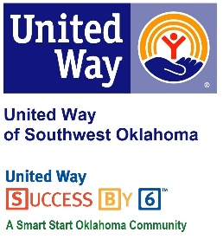
Address:  1116 SW A Ave  Lawton, OK 73501 | Media Release  September 19, 2017 | United Way Contact:  Sarah Head  Community Collaborations Director  Sarah.head@uwswok.org

Baked Potato Sale to Benefit United Way of Southwest Oklahoma

Lawton, Okla – Roadback, Inc., 1114 SW A Avenue, in Lawton will once hold a fundraiser to benefit the United Way of Southwest Oklahoma. This year, Roadback, Inc., a funded partner of United Way of Southwest Oklahoma, will sell baked potatoes, baked goods and sell 50/50 raffle tickets to benefit the United Way of Southwest Oklahoma.
Roadback, Inc. has been a United Way of Southwest Oklahoma funded partner for years. Lauren Ellis, United Way’s President & CEO, said “Like many of our partners, Roadback conducts fundraisers each year to help support the initiatives of United Way of Southwest Oklahoma. Roadback puts together fun and creative ways to raise money during our campaign season. I’m always excited to see what their newest fundraising idea is. Roadback, Inc. is an amazing program and we are so thankful to have them as a funded partner.”
Visit Roadback, Inc. (1114 SW A Avenue) on Friday, October 13, 2017 from 11AM to 2PM to purchase a baked potato with your choice of toppings and a soda for $7.00. Baked goods and 50/50 raffle tickets will be available for purchase. All proceeds benefit United Way of Southwest Oklahoma. Delivery is available for orders of 5 or more. Please call Roadback, Inc.580-357-8114 for more information.

About the United Way of Southwest Oklahoma:
The United Way helps funds 18 local partners and their 29 programs that address community issues of education, income stability, health, and basic needs.. The United Way is a charitable organization and depends on volunteers and the generosity of the local community to fulfill its mission. For more information, please visit www.uwswok.org .

