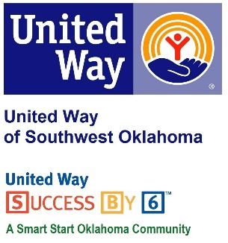
Address:  1116 SW A Ave  Lawton, OK 73501 | Media Release  July 14, 2017 | United Way Contact:  Sarah Head  (580) 355 0218  sarah.head@uwswok.org
United Way of Southwest Oklahoma 2017 Pacesetters

Lawton, Okla –United Way of Southwest Oklahoma will hold its 2017 Pacesetter luncheon hosted by Comanche County Memorial Hospital, on Friday, July 21st. These local businesses and organizations set the standard for leadership and community support by taking the challenge to get a jump start on their campaign in July and increase donations through workplace giving. The success and energy generated by our 2017 Pacesetters will help to inspire and guide other businesses to follow the lead when running their own campaigns. The annual campaign is off to a strong start with an increase of pacesetter companies to 19 this year.

“I am thrilled with the number of Pacesetter companies who have decided to step up and take the lead in our Campaign efforts this year. Their commitment to early workplace campaign efforts are critical in giving us the huge boost we need to kick off our Campaign with momentum and excitement! We are thankful for these community leaders who support our local efforts in improving lives by focusing on our four pillars of a quality life: Education, Income, Health and Basic Needs,” said Lauren Ellis, President & CEO.
Pacesetters have a strong history of support for United Way and play a crucial role in the annual campaign efforts. This year’s pacesetter companies include: Adventure Travel, Arvest Bank, BancFirst, City National Bank, Comanche County Memorial Hospital, Comanche Home Center, Cosmetic Specialty Labs, Inc., Fort Sill Federal Credit Union, FSNB, Golden Corral #912, Goodyear Tire & Rubber Company, Great Plains Improvement Foundation, Johnson and Johnson Locksmith & Door, Lawton Food Bank, Marie Detty Youth & Family Services Center, Roadback, Inc., Senior Center for Creative Living, Southwestern Medical Center, and Target Lawton.
The 19 Pacesetter Companies run an early campaign to "set the pace" for the General Campaign, which officially kicks off September 8, 2017, at United Way of Southwest Oklahoma’s 2nd Annual Blue Tie Gala Kickoff Event featuring Big Show Dueling Pianos to be held at The Apache Casino and Hotel. Sponsorship opportunities and ticket information is available by calling 580-355-0218 or visiting www.uwswok.org.

