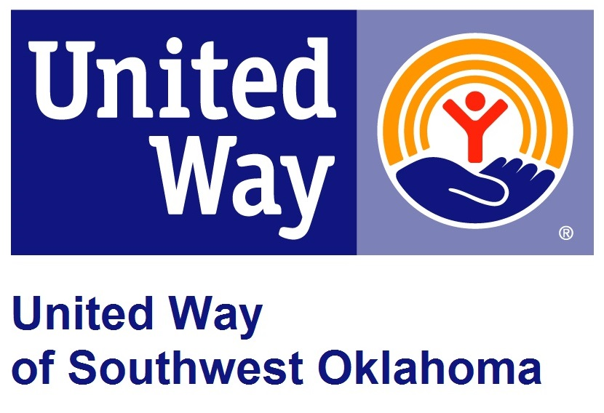
Address:  1116 SW A Ave  Lawton, OK 73501 | Media Release  April 3, 2017 | United Way Contact:  Sarah Head  (580) 355 0218  sarah.head@uwswok.org

PSO Supports National Week-of-the-Young-Child

Lawton, Okla – Public Service Company of Oklahoma (PSO) is again supporting the Week of the Young Child by providing over 2000 books for the in-house education program of United Way of Southwest Oklahoma, Success By 6.

The Week of the Young Child is an annual celebration hosted by the national Associate for the Education of Young Children celebrating early learning, children, and their teachers and families. This year April 24-28th, 2017 will mark this year’s celebration of the Week of the Young Child.

For the past several of years the PSO has chosen to partner with a local non-profit organization, United Way of Southwest Oklahoma and their in-house education initiative, Success By 6 to celebrate this week of early childhood education. This year PSO has generously provided over 2,000 books, an entire year’s worth of books, for the Success By 6’s Prescription for Reading Program, whereby all children who attend 4 local pediatricians offices get a book during their well child visit. “PSO’s generosity will ensure that these children are able to build their own home library and read with their families. Getting books into the hands of children is a vital part of learning cycle,” stated Literacy Coordinator of Success By 6, Barbara Griffin. “PSO has been a vital community partner for decades. The willingness of PSO, and their staff, to dedicate their time, talents, and treasure to benefit those in need in Southwest Oklahoma through United Way has been outstanding. Every time a volunteer opportunity arises PSO is always there to help out in any way they can. I can’t say enough about how grateful United Way is to PSO,” stated President and CEO of United Way of Southwest Oklahoma, Lauren Ellis.

About the United Way of Southwest Oklahoma:
The United Way funds 19 local agencies and their various programs that address community issues. The United Way is a charitable organization and depends on volunteers and the generosity of the local community to fulfill its mission. For more information, please visit www.uwswok.org .

###

