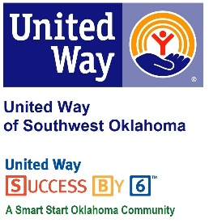
Address:  1116 SW A Ave  Lawton, OK 73501 | Media Release  October 19, 2016 | United Way Contact:  Sarah Head  Community Collaborations Director  Sarah.head@uwswok.org

Local Art Raffle to Benefit United Way of Southwest Oklahoma

Lawton, Okla – Comanche Home Center has once created a great fundraiser to benefit the United Way of Southwest Oklahoma. This time, the Comanche Home Center will be selling raffle tickets for a print of an original painting by a local artist to support United Way of Southwest Oklahoma.
The Comanche Home Center has been a valuable United Way of Southwest Oklahoma supporter for many years. Lauren Ellis, United Way’s President & CEO, said “Like many of our community supporters, Comanche Home Center conducts fundraisers each year to help support the initiatives of United Way of Southwest Oklahoma. I am always so impressed of how supportive the Comanche Home Center is of our mission to make a positive impact on our community.”
Stop by Comanche Home Center, located at #2 SW C Avenue, Lawton, to purchase your ticket for $5 to enter the drawing to win a print of the original painting “The Truce” created by local Indiahoma artist, Diana Beach Stamper. Know 100% of the proceeds will be invested in over 25 programs that focus on education, income stability, health and safety. The print is currently on display in the Comanche Home Center’s office. The drawing will take place on December 21st, 2016.

About the United Way of Southwest Oklahoma:
The United Way helps funds 19 local partners and their various programs that address community issues. The United Way is a charitable organization and depends on volunteers and the generosity of the local community to fulfill its mission. For more information, please visit www.uwswok.org .

