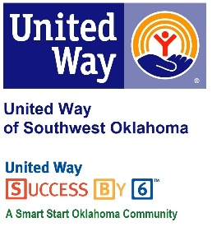
Address:  1116 SW A Ave  Lawton, OK 73501 | Media Release  October 19, 2016 | United Way Contact:  Sarah Head  Community Collaborations Director  (580) 355 0218  Sarah.head@uwswok.org

Comanche County Courthouse Supports United Way of Southwest Oklahoma through Chili Cook Off

Lawton, Okla. – The Comanche County Courthouse has once again teamed up with United Way of Southwest Oklahoma for its annual charity chili cook-off. On Monday, October 31st chefs and hungry patrons will meet at the Comanche County Courthouse Jury Selection Room to support UWSWOK.
This tradition and partnership between UWSWOK and the Comanche County Courthouse puts local dollars to work solving some of our community’s most pressing issues in the areas of Education, Income Stability, Health and Safety. Lauren Ellis, United Way’s President/CEO, said “Comanche County Courthouse chili cook-off is always a fun and well attended event. The community looks forward to this chili cook-off every year. At this event we have a chance to interact with our generous donors, share the mission and goals of our organization, and raise money to help make an impact on our community all while enjoying several bowls of wonderful chili.”
This chili cook-off will start at 11AM and wrap up around 1:30PM. To taste some of the mouthwatering chili, one trip can be purchased for $5 or $10 for all you can eat. A meal includes chili, fixings, dessert, and drink. Prizes will be awarded for; 1st Place, 2nd Place and 3rd place.

About the United Way of Southwest Oklahoma:
The United Way funds 19 local partners and their various programs (29) that address community issues. The United Way is a charitable organization and depends on volunteers and the generosity of the local community to fulfill its mission. For more information, please visit www.uwswok.org .

###

