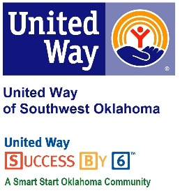
Address:  1116 SW A Ave  Lawton, OK 73501 | Media Release  October 19, 2016 | United Way Contact:  Sarah Head  Community Collaborations Director  Sarah.head@uwswok.org

Pumpkin Carving Contest to Benefit United Way of Southwest Oklahoma

Lawton, Okla – City of Lawton employees will hold a great and festive fundraiser to benefit the United Way of Southwest Oklahoma. This year, in the spirit of Halloween, City of Lawton employees will be carving pumpkins to support United Way of Southwest Oklahoma.
City of Lawton employees have been United Way of Southwest Oklahoma supporters for many years. Lauren Ellis, United Way’s President & CEO, said “We appreciate the City of Lawton employees for all they do to support our campaign and our community. I am always so impressed by the efforts they make to further our mission of making a positive impact on our community.”
Stop by City Hall, located at 212 SW 9th Street, Lawton, to cast your vote (by way of a donation) for your favorite carved pumpkin and know 100% of the proceeds will be invested in over 25 programs that focus on education, income stability, health and safety. Carved pumpkins will be on display at City Hall from October 25th to October 28th.

About the United Way of Southwest Oklahoma:
The United Way helps funds 19 local partners and their various programs that address community issues. The United Way is a charitable organization and depends on volunteers and the generosity of the local community to fulfill its mission. For more information, please visit www.uwswok.org .

