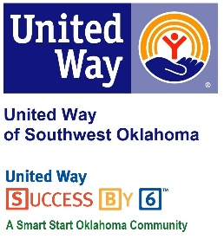
Address:  1116 SW A Ave  Lawton, OK 73501 | Media Release  March 27, 2017 | United Way Contact:  Sarah Head  Community Collaborations Director  (580) 355 0218  sarah.head@uwswok.org

Success By 6 Awarded Cotton Electric Charitable Foundation Grant

Lawton, Okla. – United Way of Southwest Oklahoma (UWSWOK)’s in-house education program, Success By 6, received notification last week that the program has been awarded two-thousand dollars from the Cotton Electric Charitable Foundation.
For over a decade, Success By 6 has been working with community partners in Southwest Oklahoma to ensure that all children have access to books through several programs. “The Cotton Electric Charitable Foundation has been a generous donor to our Success By 6 program for the last couple of years,” stated President and CEO of United Way of Southwest Oklahoma, Lauren Ellis. “Being awarded this grant validates the good work that Success By 6 and our community partners have been doing for over a decade. We are excited to see our community continue to support early childhood education.”
The funding from the Cotton Electric Charitable Foundation will allow Success By 6 continue making a difference in the lives of children and their families by ensuring that all children, regardless of the barriers they face, are ready and able to succeed in school and life.
To find out more about Success By 6 or United Way of Southwest Oklahoma please visit their facebook page or website at www.uwswok.org.

About the United Way of Southwest Oklahoma:
The United Way funds 19 local partners and their various programs (29) that address community issues. The United Way is a charitable organization and depends on volunteers and the generosity of the local community to fulfill its mission. For more information, please visit www.uwswok.org .

###

