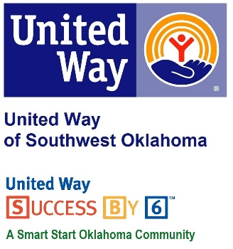
Address:  1116 SW A Ave  Lawton, OK 73501 | Media Release  April 8, 2016 | United Way Contact:  Sarah Head  (580) 355 0218  sarah.head@uwswok.org

United Way’s Success By Six Partners with PSO

Lawton, Okla – United Way of Southwest Oklahoma’s in-house education initiative Success By Six, a Oklahoma Smart Start Community has partnered with Public Service Company of Oklahoma(PSO) to provide 10 Lawton Public Scholl Pre-Kindergarten classrooms with STEM education cirriculum materials during this year’s “Week of the Young Child”, April 11-16, 2016.
This year’s theme is “Celebrating our youngest learners,” and Tim Hushbeck, Manager of Community Affairs, is taking that theme to heart as he partners with Success By Six to help insure that all children are ready to succeed in school. A generous donation form PSO totaling almost $1,500 will allow children in Pre-Kindergarten classes to get a jump start on STEM learning through a building set, class science lab and other STEM science materials.
This donation to our youngest learners is vital because, The National Association for the Education of Young Children states, “Today we know more than ever before about the importance of children’s earliest years in shaping learning and development. Yet, never before have the needs of young children and their parents been more pressing.” Sarah Head, Director of Success By Six and Community Collaborations Director for United Way of Southwest Oklahoma is excited about the partnership with PSO and hopes it will inspire new partnerships in the community so that SB6 can continue to provide these necessary STEM curriculums in all pre-kindergarten classrooms in Lawton.

About the United Way of Southwest Oklahoma:
The United Way funds 19 local agencies and their various programs that address community issues. The United Way is a charitable organization and depends on volunteers and the generosity of the local community to fulfill its mission. For more information, please visit www.uwswok.org .

###

