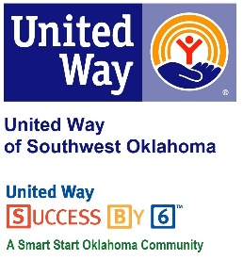
Address:  1116 SW A Ave  Lawton, OK 73501 | Media Release  September 20, 2017 | United Way Contact:  Sarah Head  Community Collaborations Director  (580) 355 0218  sarah.head@uwswok.org

Whataburger Pairs with United Way for
“Oh What A Night” Fundraiser

Lawton, Okla – Both Whataburger locations in Lawton will team up with United Way of Southwest Oklahoma for its “Oh What A Night” Fundraiser. On Wednesday, September 27, 2017 20% of all sales between the hours of 5 P.M. and 8 P.M. will be donated to UWSWOK organization.
This is the first year that UWSWOK and Whataburger will be working together on this great fundraiser that puts local dollars back into the Lawton-Fort Sill community. Lauren Ellis, United Way’s President & CEO, said “This is the first time we have been invited to do an ‘Oh What A Night’ fundraiser and we couldn’t be more pleased. We are excited to have the continued support of the Whataburger organization and look forward to a great event.”
Visit either Lawton Whataburger location for a tasty meal on September 27, between 5 and 8 PM and know that 20% of what you spend is being invested in 29 human service programs that focus on education, income, health, and basic needs. All those attending will be entered to win Whataburger for a year and United Way staff and volunteers will be onsite to provide information and answer questions about the organization.

About the United Way of Southwest Oklahoma:
The United Way funds 18 local agencies and their various programs (29) that address community issues of education, income stability, health, and basic needs. The United Way is a charitable organization and depends on volunteers and the generosity of the local community to fulfill its mission. For more information, please visit www.uwswok.org .

###

