Public Speaking Engagement Form 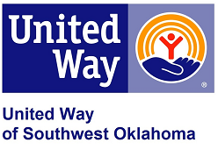

If you wish to be heard by the Board on issues not addressed on the agenda, please be so kind to complete this form and return to the Executive Director no later than 72 hours (excluding weekends and holidays) prior to the next regularly scheduled board meeting.

United Way of Southwest Oklahoma
Attn: Jennifer Cosino
Email: jennifer.cosino@uwswok.org Fax: 580.355.0810

First name: |  |  | Last name:
Position:
Company:
Address:
Phone #: |  | Email:
Speaking
Subject:
Comments:

If you wish to be heard by the Board regarding specific agenda items, please sign the form no later than 30 min prior to the scheduled start of the meeting. The Board President will then acknowledge you when the Board considers the item.

Please refer to the full Public Participation Policy for further information. You can review it at http://www.uwswok.org/marketing-resources

Date and Signature: |  | Company:

I acknowledge that I have fully read and understood the Public Participation Policy of United Way of Southwest Oklahoma for the Board Of Directors Meetings.

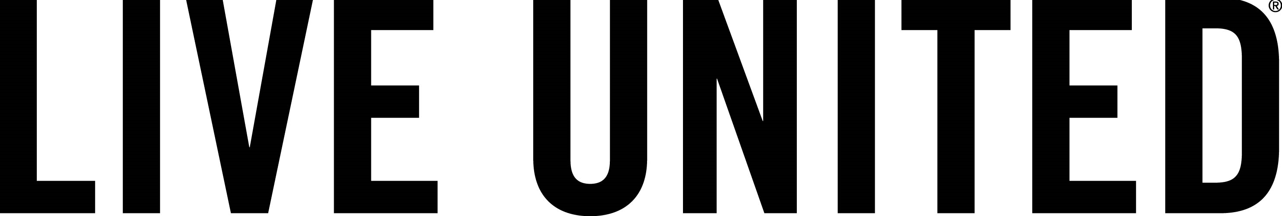

_____________________________________________________________________________________
United Way of Southwest Oklahoma, 1116 SW “A” Ave, Lawton, OK, 73502 Tel: 580.355.0218
www.uwswok.org 

