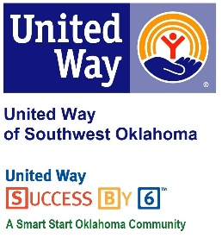
Address:  1116 SW A Ave  Lawton, OK 73501 | Media Release  October 5, 2016 | United Way Contact:  Sarah Head  Community Collaborations Director  Sarah.head@uwswok.org

Basket Raffle to Benefit United Way of Southwest Oklahoma

Lawton, Okla – Roadback, Inc., 1114 SW A Avenue, in Lawton has once created a great fundraiser to benefit the United Way of Southwest Oklahoma. This year, Roadback, Inc. has created 3 holiday baskets (Halloween, Thanksgiving, and Christmas) to be raffled off to benefit the United Way of Southwest Oklahoma.
Roadback, Inc. has been a United Way of Southwest Oklahoma partner for years. Lauren Ellis, United Way’s President & CEO, said “Like many of our partners, Roadback conducts fundraisers each year to help support the initiatives of United Way of Southwest Oklahoma. Roadback puts together fun and creative ways to raise money during our campaign season. I’m always excited to see what their newest fundraising idea is. Roadback, Inc. is an amazing program and we are so thankful to have them as a partner. ”
Visit Roadback, Inc. to purchase your raffle ticket $5 for 1 or 3 for $12 and know 100% of the proceeds will be invested in over 25 programs that focus on education, income, health and safety. The Halloween basket drawing will be held on October 14th, the Thanksgiving basket will be drawn on November 4th, and the Christmas basket will be drawn on December 2nd. Raffle tickets can also be purchase by phone at 580-357-8114.

About the United Way of Southwest Oklahoma:
The United Way helps funds 19 local partners and their various programs that address community issues. The United Way is a charitable organization and depends on volunteers and the generosity of the local community to fulfill its mission. For more information, please visit www.uwswok.org .

