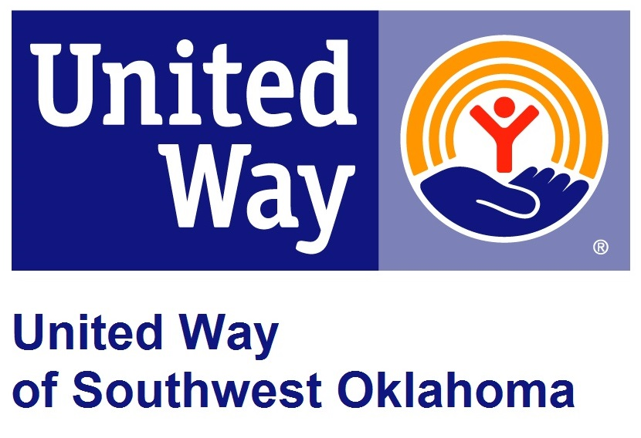
Address:  1116 SW A Ave  Lawton, OK 73501 | Media Release  June 19, 2017 | United Way Contact:  Sarah Head  (580) 355 0218  sarah.head@uwswok.org

Dollar General Supports Success By 6’s Summer Book Swap

Lawton, Okla – Dollar General is supporting 5 local book swap sites by providing over 2000 books for the in-house education program of United Way of Southwest Oklahoma, Success By 6.

Success By 6 wants to ensure that children have access to a variety of literature during the off school months. During the months of June and July Success By 6 Staff will be partnering with 2 local meal sites, as well as 3 permanent sites (WIC office/ Comanche County Health Department, Lawton Food Bank, Little Library-located outside the United Way office) to get age appropriate books, workbooks, and activity books into the hands of kids.

This is the first year that Dollar General has chosen to partner with a local non-profit organization, United Way of Southwest Oklahoma and their in-house education initiative, Success By 6 to support the Summer Book SWAP program. This year Dollar General has generously provided $2,000, which will provide an entire summer’s worth of books, for the Success By 6’s Summer Book SWAP Program. The Summer Book SWAP program is only portion of the year round Book SWAP program, but is the busiest time for the program. “During the Summer months we go through a lot of books because students have less access to libraries. So, if students can’t get to the library we bring books to them,” stated Literacy Coordinator of Success By 6, Barbara Griffin. Barbara went on to say, “Dollar General’s generosity will ensure that children are able to build their own home library and read daily with their families. Getting books into the hands of children is a vital part of learning cycle. We are proud that Dollar General selected our program to further early childhood education in Southwest Oklahoma.”

About the United Way of Southwest Oklahoma:
The United Way funds 19 local agencies and their various programs that address community issues. The United Way is a charitable organization and depends on volunteers and the generosity of the local community to fulfill its mission. For more information, please visit www.uwswok.org .

###

