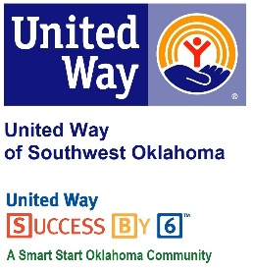
Address:  1116 SW A Ave  Lawton, OK 73501 | Media Release  October 5, 2016 | United Way Contact:  Sarah Head  Community Collaborations Director  (580) 355 0218  Sarah.head@uwswok.org

Comanche Home Center Supports United Way of Southwest Oklahoma through Breakfast Burrito Sale

Lawton, Okla. – The Comanche Home Center in Lawton has once again teamed up with United Way of Southwest Oklahoma to help raise money for their annual campaign. On Monday, October 17th beginning at 7:30AM homemade breakfast burritos will be available outside the contracting department of Comanche Home Center #2 SW C Avenue.
For several years the Comanche Home Center join UWSWOK to raise funds that puts local dollars to work solving some of our community’s most pressing issues in the areas of Education, Income Stability, Health and Safety. Lauren Ellis, United Way’s President/CEO, said “We are so grateful for continued support from great community partners like Comanche Home Center. Every year the Comanche Home Center puts together an amazing fundraiser to support United Way of Southwest Oklahoma and our initiatives. We are so thankful for community partners like CHC who continue to support the positive changes that are happening in our community.”
The breakfast burrito fundraiser will feature 3 different types of homemade burritos; sausage egg and cheese, egg and cheese, spicy pulled pork and egg and cheese. Comanche Home Center will begin selling burritos for $2 each at 7:30AM on October 17th right outside of their contracting department. All proceeds will benefit the United Way of Southwest Oklahoma and their partners.

About the United Way of Southwest Oklahoma:
The United Way funds 19 local partners and their various programs (29) that address community issues. The United Way is a charitable organization and depends on volunteers and the generosity of the local community to fulfill its mission. For more information, please visit www.uwswok.org .

###

