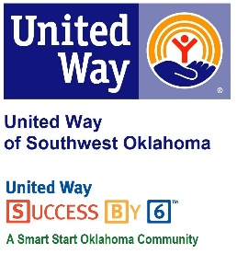
Address:  1116 SW A Ave  Lawton, OK 73501 | Media Release  January 30, 2017 | United Way Contact:  Sarah Head  Community Collaborations Director  (580) 355 0218  sarah.head@uwswok.org

Success By 6 Awarded State Grant

Lawton, Okla. – United Way of Southwest Oklahoma (UWSWOK)’s in-house education program, Success By 6, received notification late last week that the program had been chosen as one of five grant recipients from Smart Start Oklahoma for the remainder of this fiscal year.
For over a decade, Success By 6 has been working with community partners in Southwest Oklahoma to ensure that all children have access to books through several programs. “This grant is unique in that so few applicants were selected for funding,” stated President and CEO of United Way of Southwest Oklahoma, Lauren Ellis. “Being awarded this grant validates the good work that Success By 6 and our community partners have been doing for over a decade. We are excited to see our state continue to see the importance of early childhood education.”
The over $30,000 in funding from Smart Start Oklahoma will allow Success By 6 to research the deeper issues affecting early childhood education and make a plan for workable solutions. Success By 6 will report on the findings of the research at a Oklahoma Partnership School Readiness board meeting in May of 2017.
To find out more about Success By 6 or United Way of Southwest Oklahoma please visit their facebook page or website at www.uwswok.org.

About the United Way of Southwest Oklahoma:
The United Way funds 19 local partners and their various programs (29) that address community issues. The United Way is a charitable organization and depends on volunteers and the generosity of the local community to fulfill its mission. For more information, please visit www.uwswok.org .

###

