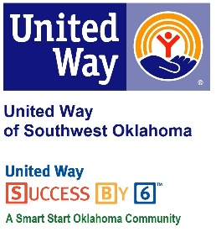
Address:  1116 SW A Ave  Lawton, OK 73501 | Media Release  September 19, 2017 | United Way Contact:  Sarah Head  Community Collaborations Director  (580) 355 0218  sarah.head@uwswok.org

Success By 6 Awarded a Grant from The Lawton Community Foundation

Lawton, Okla. – United Way of Southwest Oklahoma’s (UWSWOK) in-house education program, Success By 6, received notification this week that the program has been awarded a $3,500 grant from The Lawton Community Foundation.
For the past 3 years, the Success By 6 program has received funding from The Lawton Community Foundation to continue ensuring that all children have access to books through several programs. “Being awarded this grant validates the good work that Success By 6 and our community partners have been doing for over a decade,” stated President and CEO of United Way of Southwest Oklahoma, Lauren Ellis. “We are excited that The Lawton Community Foundation continues to see the importance of early childhood education and is willing to step up year after year and help make positive change happen.”
To find out more about Success By 6 or United Way of Southwest Oklahoma please visit their facebook page or website at www.uwswok.org.

About the United Way of Southwest Oklahoma:
The United Way funds 18 local partners and their various programs (29) that address community issues of education, income stability, health, and basic needs. The United Way is a charitable organization and depends on volunteers and the generosity of the local community to fulfill its mission. For more information, please visit www.uwswok.org .

###

