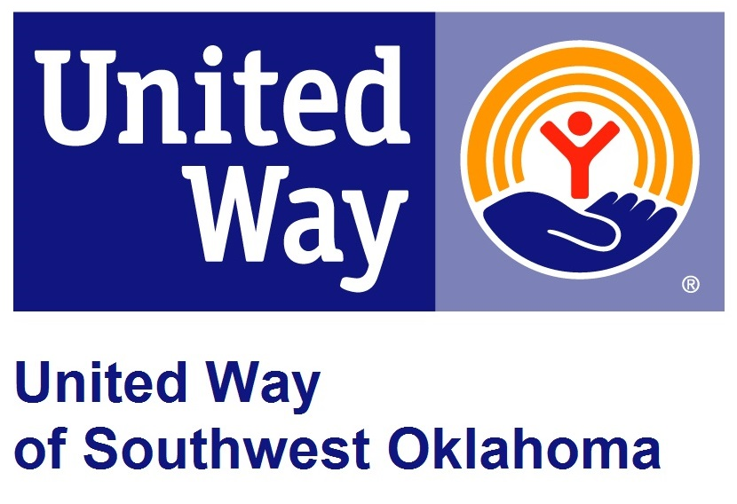
Address:  1116 SW A Ave  Lawton, OK 73501 | Media Release  February 27, 2017 | United Way Contact:  Sarah Head  (580) 355 0218  Sarah.head@uwswok.org

United Way to Announce its 23rd Annual
David Hegwood Day of Caring

Lawton, Okla – United Way of Southwest Oklahoma will host the 23rd Annual David Hegwood Day of Caring on Friday, April 28, 2017, at 8:00 a.m. at the Worley Seminar Center, Building 300 at Great Plains Technology Center, 4500 SW Lee Blvd.
Day of Caring began in 1994 and has evolved into a massive effort that brings volunteers face-to-face with local nonprofit organizations. In 2012, the Day of Caring was renamed the David Hegwood Day of Caring in honor of a long-time United Way volunteer, advocate and community leader. This well-known event provides local human service agencies the opportunity to establish relationships with local businesses and strengthen the volunteers’ awareness of their mission. Local volunteers will fan out over our community to complete a variety of community service projects in the Lawton-Fort Sill area.
For the Day of Caring to be a success United Way will need approximately 250 volunteers. If your organization, civic group, or business would like to provide volunteers for the 23rd Annual David Hegwood Day of Caring please visit our website at www.uwswok.org and complete the form titled Day of Caring Volunteer Information form.
Southwestern Medical Center has once again generously sponsored the event by providing a breakfast that is open to the public. All those interested in attending the breakfast should RSVP by Monday, April 11th, by calling the United Way office at 580. 355.0218.

About the United Way of Southwest Oklahoma:
The United Way funds 19 local agencies and their various programs that address community issues. The United Way is a charitable organization and depends on volunteers and the generosity of the local community to fulfill its mission. For more information, please visit www.uwswok.org .

###

