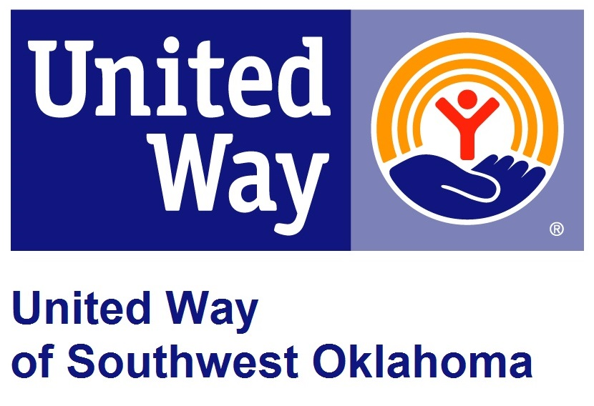
Address:  1116 SW A Ave  Lawton, OK 73501 | Media Release  April 8, 2016 | United Way Contact:  Tiffany Hatfield  (580) 355 0218  tiffany.hatfield@uwswok.org

United Way to Announce its annual David Hegwood Day of Caring

Lawton, Okla – United Way of Southwest Oklahoma will host the 22nd Annual David Hegwood Day of Caring on Friday, April 15, 2016, at 8:00 a.m. at the Worley Seminar Center, Building 300 at Great Plains Technology Center, 4500 SW Lee Blvd.
Day of Caring began in 1994 and has evolved into a massive effort that brings volunteers face-to-face with local nonprofit organizations. In 2012, the Day of Caring was renamed the David Hegwood Day of Caring in honor of David Hegwood, a long-time volunteer of United Way and the community. This well-known event provides local human service agencies the opportunity market their services to the public, establish relationships with local businesses, and strengthen the volunteers’ awareness of their mission. Local volunteers will fan out over our community to complete a variety of community service projects in the Lawton-Fort Sill area. This year there will be over 250 volunteers from 27 local business partners to impact the needs of over a dozen local schools and organizations that service the community.
Southwestern Medical Center has once again sponsored the event by providing a breakfast that is open to the public. All those interested in attending the breakfast should RSVP by Monday, April 11th, by calling the United Way office at 580. 355.0218.

About the United Way of Southwest Oklahoma:
The United Way funds 19 local agencies and their various programs that address community issues. The United Way is a charitable organization and depends on volunteers and the generosity of the local community to fulfill its mission. For more information, please visit www.uwswok.org .

###

