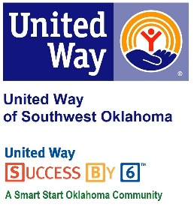
Address:  1116 SW A Ave  Lawton, OK 73501 | Media Release  August 9, 2017 | United Way Contact:  Sarah Head  Community Collaborations Director  (580) 355 0218  Sarah.head@uwswok.org

Goodyear-Lawton Supports United Way of Southwest Oklahoma through Golf Tournament

Lawton, Okla. – The Goodyear plant in Lawton has once again teamed up with United Way of Southwest Oklahoma for its annual charity golf tournament. On Friday, October 13, 2017 golfers will have a shotgun start at Noon at the Fort Sill Golf Course to support UWSWOK.
This more than a decade-old tradition will again join UWSWOK and Goodyear-Lawton together on this great fundraiser that puts local dollars to work solving some of our community’s most pressing issues in the areas of Education, Income Stability, Health and Safety. Lauren Ellis, United Way’s President/CEO, said “The Goodyear Charity Golf Tournament is always a fun and well attended event. We have a chance to interact with our generous donors, share the mission and goals of our organization, and raise money to help make an impact on our community all while enjoying a fun day on the golf course.”
This golf tournament is a 4 person scramble with an entry fee of $75.00 per person. Green fees, golf cart, refreshments, door prizes and lunch are included with the cost of entry. Prizes will be awarded for; 1st Place Team, 2nd Place Team, Hole-In-One, Closest to the Pin, and Longest Drive. Sponsorship opportunities are available, and are a great way to show community support. The deadline for entries and sponsorships is Wednesday, October 4th, 2017. For more information about sponsorships or to enter your team in the golf tournament contact Casey Honeycutt at 580-531-5806. United Way staff and volunteers will be onsite to provide information and answer questions about the organization.

About the United Way of Southwest Oklahoma:
The United Way funds 19 local partners and their various programs (29) that address community issues. The United Way is a charitable organization and depends on volunteers and the generosity of the local community to fulfill its mission. For more information, please visit www.uwswok.org .

###

