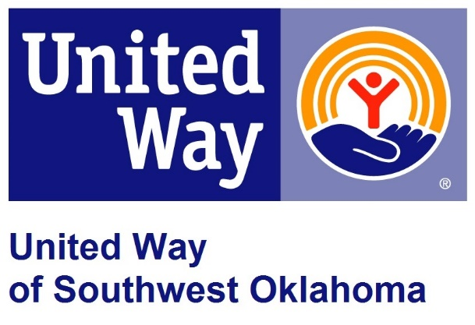

United Way of Southwest Oklahoma New Agency Policy

New agencies desiring to be a funded partner of United Way of Southwest Oklahoma should request a new partner application from the United Way of Southwest Oklahoma beginning March 1st of each year and must submit a completed application no later than April 30th of each year. A completed application includes the new partner application and all attachments requested on that form. Incomplete applications will not be considered. Agencies will be notified by June 1st if their application has been approved by the board of directors as a partner agency. If a new agencies application is approved, they will be eligible to apply for funding beginning in January of the following year. Acceptance of new partner agencies will be determined by the availability of funds and approval by the United Way of Southwest Oklahoma board of directors.

Any previously funded agency that has not received funding within the past 18 months will be eligible to apply for funding during the next funding cycle contingent on them addressing any requirements and recommendations from their most recent CIC visit. If it has been more than 18 months since the agency has received its last disbursement, the agency will be required to follow the new agency guidelines.

