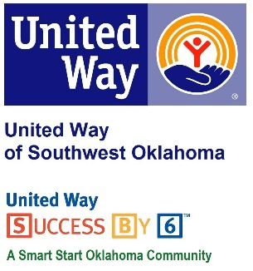
Address:  1116 SW A Ave  Lawton, OK 73501 | Media Release  June 6, 2017 | United Way Contact:  Sarah Head  (580) 355 0218  sarah.head@uwswok.org

Save the Date: United Way to Host 2nd Annual Blue Tie Gala Campaign Kickoff Fundraiser

Lawton, Okla – United Way of Southwest Oklahoma is pleased to announce it will be hosting its 2nd Annual Blue Tie Gala on Friday, September 8, 2017 at the Apache Casino Hotel in Lawton, OK.

This year’s event will once again feature the incredible “BIG SHOW Dueling Pianos,” a fun and multidimensional music group whose many accolades include, “Best Variety Entertainment,” by The Village Voice, NYC and “Best Dueling Piano Act,” at Walt Disney World, Orlando. Their involvement with charitable organizations is extensive and all the money they receive at the event will be given directly back to the United Way of Southwest Oklahoma.

“I am so excited for our 2nd Annual Blue Tie Gala. Last year’s event was a great success, and I am looking forward to another sold out evening of dueling pianos, food, and auction items as we celebrate the beginning of our Annual Fundraising Campaign,” said Lauren Ellis, President and CEO of United Way of Southwest Oklahoma. “The community’s support of this event means so much to United Way of Southwest Oklahoma, and we plan to make it an evening to remember!”
This event celebrates the official kickoff of the annual campaign that funds 29 local human service programs in education, income stability, health, and basic needs that are provided through our 17 funded partner agencies.
More information about this event is coming soon!
About the United Way of Southwest Oklahoma:
The United Way funds 17 local partners and their various programs that address community issues of education, income stability, health, and basic needs. The United Way is a charitable organization and depends on volunteers and the generosity of the local community to fulfill its mission. For more information, please visit www.uwswok.org .

###

